Intermediate guide on how to use Microsoft Word

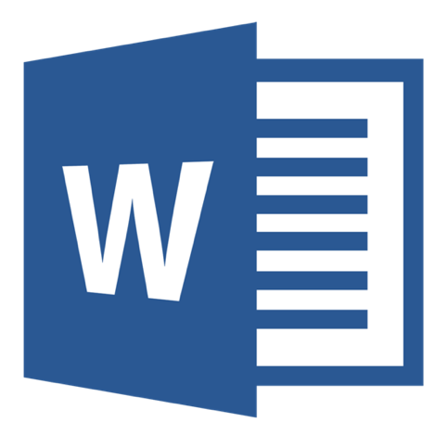

|  |  |
| --- | --- |
| **guide on How To:** | **Page Number** |
| Download/Open application | 2 |
| Create document | 2 |
| Create template document | 3 |
| Add and edit text | 3 |
| Add pictures, shapes, chart, and more | 3 |
| Use styles | 4 |
| Apply themes | 4 |
| Check spelling and grammar | 5 |
| Remove hyperlinks from copied website links | 5 |
| Save a file | 6 |
| Print | 7 |
| Use shortcuts for Microsoft Word | 8 |

**Download Application**

You can download Microsoft 365 for free on your PC/Laptop, Tablet or Smartphone using your Microsoft 365 login:

* **Microsoft 365 username** [studentnumber@fecolleges.london](mailto:studentnumber@fecolleges.london) and password

(e.g. [S0123456@fecolleges.london](mailto:S0123456@fecolleges.london) / [AC102356@fecolleges.london](mailto:AC102356@fecolleges.london) / [20123456@fecolleges.london](mailto:20123456@fecolleges.london))

**PC/Laptop**

1. Open link using your web browser: <https://www.microsoft.com/en-gb/microsoft-365>
2. Sign in with your **Microsoft 365 username** and password
3. Select **Install** located at the top right of the web page.

**Tablet/Smartphone**

1. Search **Word** on Apple App Store/Google Play and **download**.
2. Open application and sign in with your **Microsoft 365 username** and password.

**Open Application**

1. Search your computer for Microsoft Word and open.
   * In Windows, click **Start** Start button > **Microsoft Word**.
   * On Mac, go to the **Applications** folder and click **Microsoft Word**.
   * On Tablet/Smartphone, tap the **Word** icon.
2. Sign in with your **Microsoft 365 username** and password

**Create a document**

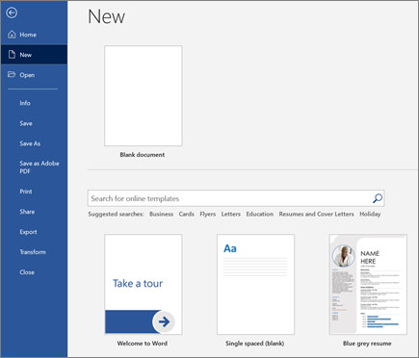

1. On the **File**tab, click **New**.
2. In the **Search for online templates** box, enter the type of document you want to create, and press ENTER.

**Tip:** To start with empty page, select **Blank document**. Or, to use CV template or Letter template write in search bar.

**Create a Template Document**

Start your document with help from a template.

1. Click a template to see a preview. Click the arrows on the side of the preview to see more templates.

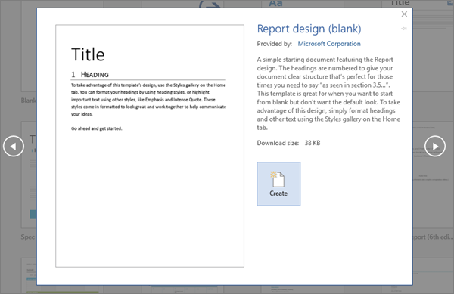

1. Select **Create**.

**Add and edit text**

1. Place the cursor and type some text.
2. To edit, select/highlight the text and then select an option: **Bold**, *Italic*, • Bullets, etc. You can change the colour, size and style.

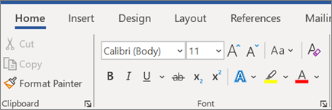

**Add Pictures, Shapes, Chart, and more**

1. Select the **Insert** tab.
2. Select what you want to add:
   * **Tables** - select **Tables**, hover over the size you want, and select it.
   * **Pictures** - select **Pictures**, browse for the picture you want, and select **Insert**.
   * **Online Pictures** - select **Online Pictures**, search and choose the picture you want, and select **Insert**.
   * **Shapes** - select **Shapes**, and then select a shape from the drop-down.
   * **Icons** - select **Icons**, choose the one you want, and select **Insert**.
   * **Chart** - select **Chart**, select the chart you want, and select **OK**.
   * **Screenshot** - select **Screenshot** and select one from the drop-down.

**Use Styles**

**Styles** templates apply a steady font, font size, font colour, and spacing to headings, paragraphs, and titling throughout your document.

1. Select/highlight the words, paragraph, list or table you want to edit.
2. On the **Home** tab, select a style.

If you don't see the style you want, click the **More** button  More button to expand the gallery.

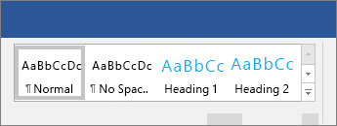

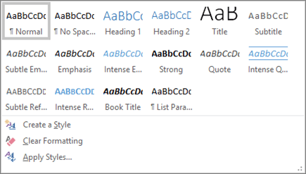

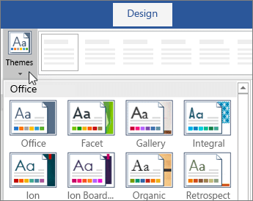**Apply Themes**

**Themes** add a professional look to your document.

1. Select **Design** > **Themes**.
2. Point to a theme to preview how it will look.
3. Select the theme you want.

**Check spelling and grammar**

Words which are spelt incorrectly will have a red squiggly underline and grammar mistakes with a blue/green double underline.

1. Right-click the word with your mouse.
2. Select a correction or select **Ignore**.

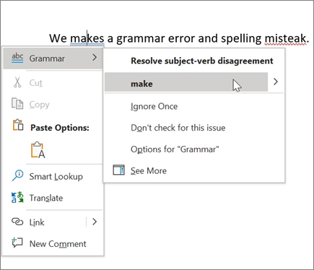

**Remove hyperlinks from copied website links**

Removing a hyperlink keeps the text; it just removes the link.

* 1. Right-click the link and choose **Remove Hyperlink**.

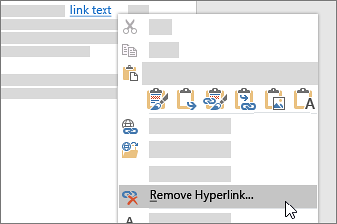

**Save a file**

1. Select **File** > **Save As**.

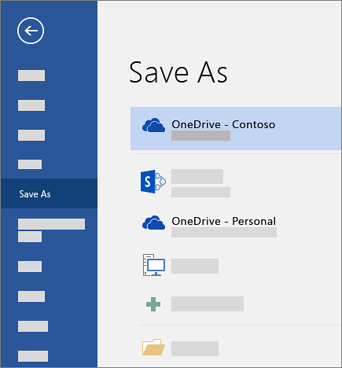

1. Select where you want to save the file.

You can save to your computer, OneDrive, or another USB location. Save your files to OneDrive if you'd like to get to them anywhere using the internet.

1. Enter a file name.
2. Select **Save**.

**Printing**

Print and Print Preview are in the same place: go to **File** > **Print** (or press Ctrl+P)

1. Select **File**>**Print**. On the right, you’ll see a preview of your document. On the left, you'll see the **Print** button and the configurable **Settings**.
2. To see each page, click the arrow at the bottom of the preview, and if the text is too small, use the zoom slider to adjust it.

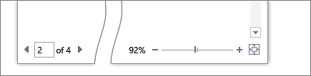

1. Choose the number of copies you want and choose the printer to use.
2. Explore**Settings** to print on both sides of the paper, change the paper orientation, and other configurations. These functions will differ according to the capabilities of your printer.

**Note:** For some settings, like printing in colour or black and white, select **Printer Properties**.

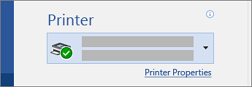

**Use shortcuts for Microsoft Word**

This table shows the most frequently used shortcuts in Word Windows.

| **Action** | **Shortcut Keys** |
| --- | --- |
| Open a document. | Ctrl+O |
| Create a new document. | Ctrl+N |
| Save the document. | Ctrl+S |
| Close the document. | Ctrl+W |
| Cut the selected content to the Clipboard. | Ctrl+X |
| Copy the selected content to the Clipboard. | Ctrl+C |
| Paste the contents of the Clipboard. | Ctrl+V |
| Select all document content. | Ctrl+A |
| Apply bold formatting to text. | Ctrl+B |
| Apply italic formatting to text. | Ctrl+I |
| Apply underline formatting to text. | Ctrl+U |
| Decrease the font size by 1 point. | Ctrl+[ |
| Increase the font size by 1 point. | Ctrl+] |
| Center the text. | Ctrl+E |
| Align the text to the left. | Ctrl+L |
| Align the text to the right. | Ctrl+R |
| Cancel a command. | Esc |
| Undo the previous action. | Ctrl+Z |
| Redo the previous action, if possible. | Ctrl+Y |
| Adjust the zoom magnification. | Alt+W, Q, then tab in Zoom dialog box to the value you want. |
| Split the document window. | Ctrl+Alt+S |
| Remove the document window split. | Alt+Shift+C or Ctrl+Alt+S |