Intermediate guide on how to use Microsoft PowerPoint



|  |  |
| --- | --- |
| **guide on How To:** | **Page Number** |
| Download/Open application | 2 |
| Create a presentation | 2 |
| Add a slide | 3 |
| Add and format text | 3 |
| Add a picture, shape, or chart | 4 |
| Insert WordArt | 4 |
| Check spelling | 5 |
| Add a table | 5 |
| Insert a picture | 5 |
| Design themes | 6 |
| Add transitions | 6 |
| Add animations | 6 |
| Save your presentation | 7 |
| Rename your presentation | 7 |
| Print your presentation | 8 |
| Use shortcuts for Microsoft PowerPoint | 9 |

**Download Application**

You can download Microsoft 365 for free on your PC/Laptop, Tablet or Smartphone using your Microsoft 365 login:

* **Microsoft 365 username** [studentnumber@fecolleges.london](mailto:studentnumber@fecolleges.london) and password

(e.g. [S0123456@fecolleges.london](mailto:S0123456@fecolleges.london) / [AC102356@fecolleges.london](mailto:AC102356@fecolleges.london) / [20123456@fecolleges.london](mailto:20123456@fecolleges.london))

**PC/Laptop**

1. Open link using your web browser: <https://www.microsoft.com/en-gb/microsoft-365>
2. Sign in with your **Microsoft 365 username** and password.
3. Select **Install** located at the top right of the web page.

******Tablet/Smartphone**

1. Search **PowerPoint** on Apple App Store/Google Play and **download**.
2. Open application and sign in with your Microsoft 365 username and password.

**Open Application**

1. Search your computer for Microsoft PowerPoint and open.
   * In Windows, click **Start** Start button > **Microsoft PowerPoint**.
   * On Mac, go to the **Applications** folder and click **Microsoft PowerPoint**.
   * On Tablet/Smartphone, tap the **PowerPoint** icon.
2. Sign in with your **Microsoft 365 username** and password

**Create a presentation**

1. Open PowerPoint.
2. Select an option:
   * Select **Blank Presentation** to create a presentation with empty page.
   * Select one of the templates.
   * 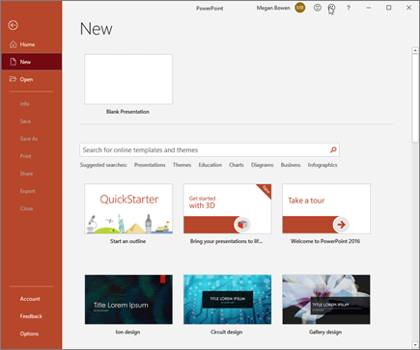Select **Take a Tour**, and then select **Create**, to see tips for using PowerPoint.

**Add a slide**

1. Select the slide you want your new slide to follow.
2. Select **Home** > **New Slide**.
3. Select **Layout** and the you type want from the drop-down.

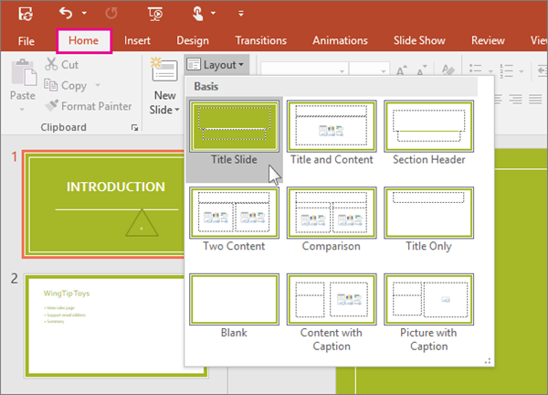

**Add and format text**

1. Place the cursor where you want, and type.
2. Select the text, and then select an option on the **Home** tab: **Font**, **Font size**, **Bold**, **Italic**, **Underline**, ...
3. To create bulleted or numbered lists, select the text, and then select **Bullets** or **Numbering**.

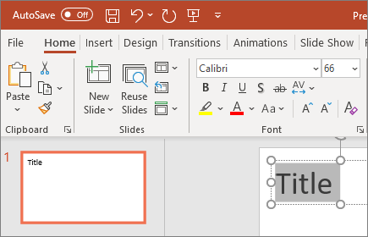

**Add a picture, shape, or chart**

1. Select **Insert**.
2. To add a picture:
   * Select **Picture**.
   * Browse for the picture you want and select **Insert**.
3. To add a shape, art, or chart:
   * Select **Shapes**, **Icons**, **SmartArt**, or **Chart**.
   * Select the one you want.

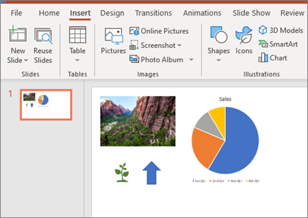

**Insert WordArt**

1. Click **Insert** > **WordArt** and pick the WordArt style you want.

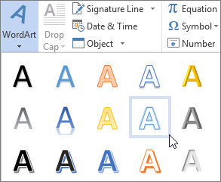

In the WordArt gallery, the letter A represents the different designs that are applied to all text you type.

**Check your entire presentation spelling**

1. Select **Review** > **Spelling**.
2. In the **Spelling** pane, select the correct spelling from the suggestions.
3. Select **Change** to fix the error or **Change All** if it appears more than once in the document.  
   Or you can select:
   * **Ignore**: Ignores the error and removes the red squiggly line.
   * **Ignore All**: Ignores the error and removes the red squiggly line for all instances in the presentation.
   * **Add**: Adds the spelling to the dictionary so that spelling will not show an error in the future.

**Add a table**

1. Select **Insert** > **Table** > **Insert Table**.
2. In the **Insert Table** dialog box, select how many columns and rows you want.
3. Select **OK**.

Add table styles

1. Select the table.
2. Select **Design** and choose from the **Table Styles**. Hover to preview styles.

Select **More** More button to see more **Table Styles**.

Change table layout

1. Select the table.
2. Select **Layout**.
3. Choose from the different groups to make changes:
   * **Rows & Columns**
   * **Merge**
   * **Cell Size**
   * **Alignment**
   * **Table Size**

**Insert a picture from your computer on your slide**

1. 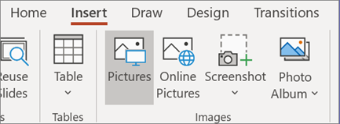Click where you want to insert the picture on the slide.
2. On the **Insert** tab, in the **Images** group, click **Pictures**.
3. In the dialog box that opens, browse to the picture that you want to insert, click that picture, and then click **Insert**.

**Tip:** If you want to insert multiple pictures at the same time, press and hold the Ctrl key while you select all the pictures you want to insert.

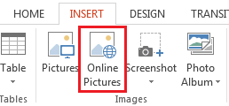**Insert a picture from the web on your slide**

1. Click where you want to insert the picture on the slide.
2. On the **Insert** tab, in the **Images** group, click **Online Pictures**.
3. **(PowerPoint 2013)** In the**Bing Image Search** box, type what you are searching for, and press Enter.
4. Click the picture you want to add and click **Insert**.

**Tip:** After you insert a picture, you can change its size and position. To do so, right-click the picture, and click **Format Picture**. You can then use the **Format Picture** tools that are on the right of your slide.

**Design Themes**

1. Select the **Design** tab.
2. Select one of the **Themes**.
3. Select one of the **Design** **Options** which are listed.

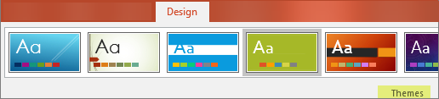

**Add Transitions**

To add a special effect, to transition from one slide to another:

1. Select the slide you want to add a transition to.
2. On the **Transitions** tab, select the effect you want.
3. Select **Effect Options** to change how the transition happens: **From Right**, **From Left**, ...

To undo a transition, select **None**.

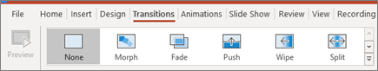

**Add Animations**

To animate text or objects on a slide:

1. Select the text or object you want to animate.
2. On the **Animations** tab, select **Add Animation**, and select the animation you want from the drop-down.

To animate one line of text at a time, select one line of text, select an animation, select the next line of text, select an animation, ...

1. For **Start**, select **When Clicked**, **With Previous**, or **After Previous**.

You can also select the **Duration** or **Delay**.

**Save your presentation**

When you save your files to the cloud, you can share and collaborate with others, and get to your files from anywhere - on your computer, tablet, or phone.

1. 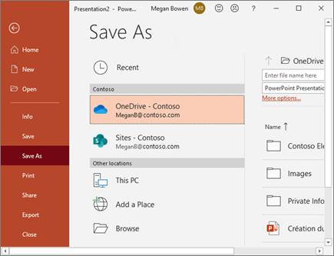Select **File > Save As**.
2. Select **OneDrive**.

Save personal files to **OneDrive - Personal**, and work files to your company OneDrive. You can also save to another location, like your computer device or USB (to save in your computer or USB, please select Browse and then choose the folder you want to save the file in).

**Rename a presentation**

1. Select the file name on the title bar.
2. 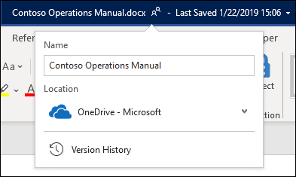In the menu that appears you can rename the file, select a new location to move it to, or see the version history for the file.

**Offline**

When you're online, AutoSave is always on and saves your changes as you work. If at any time you lose your Internet connection or turn it off, any pending changes will sync as soon as you’re back online.

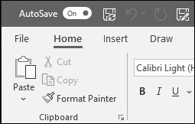

**Print your presentation**

1. Select **File** > **Print**.
2. For **Printer**, select the printer you want to print to.
3. For **Settings**, select the options you want:
   * **Slides**: From the drop-down, choose to print all slides, selected slides, or the current slide. Or, in the **Slides** box, type which slide numbers to print, separated by a comma.
   * **Colour**: Choose whether you want colour, grayscale, or pure black and white.
4. Under **Settings**, click the second box (which defaults to say **Full Page Slides**), then under **Print Layout**, click **Notes Pages**.

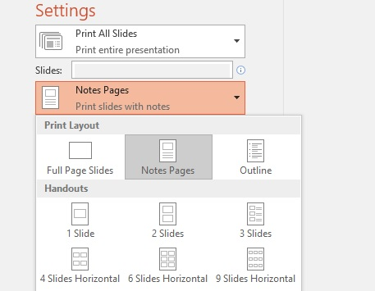

1. For **Copies**, select how many copies you want to print.
2. Select **Print**.

**Use shortcuts for Microsoft PowerPoint**

This table shows the most frequently used shortcuts in PowerPoint Windows.

| **Action** | **Shortcut Keys** |
| --- | --- |
| Create new presentation. | Ctrl+N |
| Add a new slide. | Ctrl+M |
| Make selected text bold. | Ctrl+B |
| Change the font size for selected text. | Alt+H, F, S |
| Open the **Zoom** dialog. | Alt+W, Q |
| Cut selected text, object, or slide. | Ctrl+X |
| Copy selected text, object, or slide. | Ctrl+C |
| Paste cut or copied text, object, or slide. | Ctrl+V |
| Undo the last action. | Ctrl+Z |
| Save the presentation. | Ctrl+S |
| Insert a picture. | Alt+N, P |
| Insert a shape. | Alt+N, S, H |
| Select a theme. | Alt+G, H |
| Select a slide layout. | Alt+H, L |
| Go to the next slide. | Page down |
| Go to the previous slide. | Page up |
| Go to the Home tab. | Alt+H |
| Go to the Insert tab. | Alt+N |
| Start the slide show. | F5 |
| End the slide show. | Esc |
| Close PowerPoint. | Ctrl+Q |