Intermediate guide on how to use Microsoft Outlook (Email)

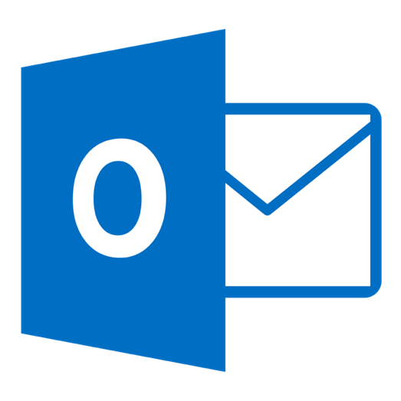

|  |  |
| --- | --- |
| **guide on How To:** | **Page Number** |
| Download/Open application | 2 |
| Add an email account | 2 |
| Create and send email | 2 |
| Reply or Forward email | 3 |
| Add an attachment to your email | 3 |
| Use Focused Inbox | 4 |
| Schedule an appointment on Outlook Calendar | 4 |
| Print emails | 5 |
| Use shortcuts for Microsoft Word | 6 |

**Download Application**

You can download Microsoft 365 for free on your PC/Laptop, Tablet or Smartphone using your Microsoft 365 login:

* **Microsoft 365 username** [studentnumber@fecolleges.london](mailto:studentnumber@fecolleges.london) and password

(e.g. [S0123456@fecolleges.london](mailto:S0123456@fecolleges.london) / [AC102356@fecolleges.london](mailto:AC102356@fecolleges.london) / [20123456@fecolleges.london](mailto:20123456@fecolleges.london))

**PC/Laptop**

1. Open link using your web browser: <https://www.microsoft.com/en-gb/microsoft-365>
2. Sign in with your **Microsoft 365 username** and password.
3. Select **Install** located at the top right of the web page.

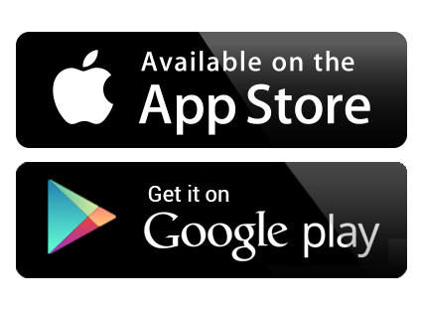**Tablet/Smartphone**

1. Search **Outlook** on Apple App Store/Google Play and **download**.
2. Open application and sign in with your **Microsoft 365 username** and password.

**Open Application**

1. Search your computer for Microsoft Outlook and open.
   * In Windows, click **Start** Start button > **Microsoft Outlook**.
   * On Mac, go to the **Applications** folder and click **Microsoft Outlook**.
   * On Tablet/Smartphone, tap the **Outlook** icon.
2. Sign in with your **Microsoft 365 username** and password

**Add an email account**

1. Open Outlook and select **File** > **Add Account**.

If you haven't launched Outlook before, you'll see a welcome screen.

1. Sign in with your Microsoft 365 username [studentnumber@fecolleges.london](mailto:studentnumber@fecolleges.london) and password.

(e.g. [S0123456@fecolleges.london](mailto:S0123456@fecolleges.london) / [AC102356@fecolleges.london](mailto:AC102356@fecolleges.london) / [20123456@fecolleges.london](mailto:20123456@fecolleges.london))

1. If prompted, enter your password and select **OK**.
2. Select **Finish**.

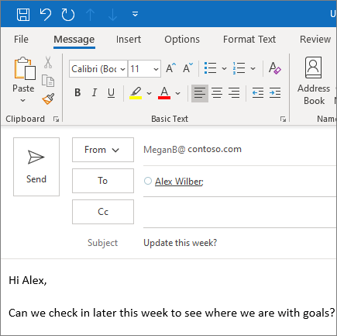

**Create and send email**

1. Choose **New Email** to start a new message.
2. Enter a name or email address in the **To** field.
3. In **Subject**, type the subject of the email message.
4. Place the cursor in the body of the email message, and then start typing.
5. After typing your message, choose **Send**.

**Reply to an email**

1. Select an email to reply to.
2. Select **Reply**.
3. Type a response in.
4. Select **Send**.

**Forward to share email with others**

1. Select an email to forward.
2. Select **Forward**.
3. Type in who you'd like to forward to.
4. Add a note in the email body if you'd like.
5. Select **Send**.

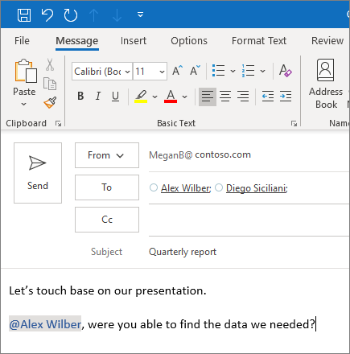**Use @mentions to get someone's attention**

1. In the body of the email message or calendar invite, enter the **@** symbol and the first few letters of the contact's first or last name.
2. When Outlook offers you one or more suggestions, choose the contact you want to mention.

By default, their full name is included. You can delete a portion of the mention, for example, everything other than the person's first name.

1. The mentioned contact is added to the **To** line of the email or the meeting invite.

**Send a file with your email as an attachment.**

**Add an attachment**

1. Select **Home** >**New** **Email**. Or, for an existing email, select **Reply/Reply** **All** or **Forward**.
2. Select **Home** >**Attach** **File**, and choose an option:
   * **Recent** **items** - select a file from the list of the files you have saved or worked with recently. These files could be saved locally, or they might exist on internal network locations and Group Files.
   * **Browse** **Web** **Locations** - select files from OneDrive.
   * **Browse This PC** - select a file from your local computer.
3. To upload attachment, find the file and select **Attach** **Item**
4. If you want to remove an attached file, select the down arrow, and then select **Remove** **Attachment** in the drop-down list.

**Focused Inbox**

Focused Inbox helps you focus on the emails that matter most. It separates your inbox into two tabs—**Focused** and **Other**.

If messages aren't sorted the way you like, you can move them and set where to deliver future messages from that sender.

1. Select the **Focused** or **Other** tab.
2. Right-click the message you want to move and select **Move to Other** or **Move to Focused**.

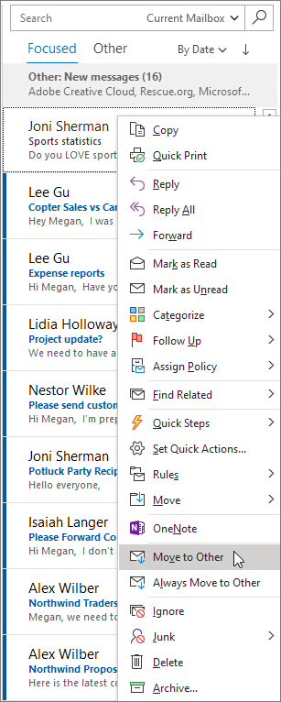

**To turn the Focused Inbox on or off:**

* Select **View** > **Show Focused Inbox**.

**Schedule an appointment**

1. In **Calendar**, select **New Appointment**.
2. Add a **Subject**, **Location**, and the start and end times.
3. Select **Invite Attendees** to turn the appointment into a meeting.

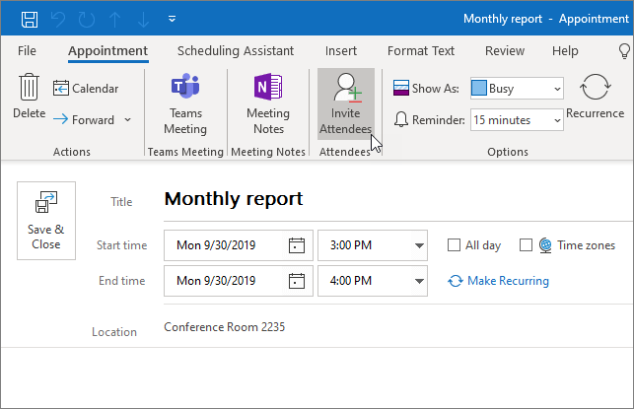

1. Select **Save & Close** to finish OR **Send** if it's a meeting.

**Search in Outlook lets you quickly find email, contacts, or events.**

1. Select the **Search** box.
2. Type what you're looking for.
3. To refine results, Select Filters and change options like **Folders**, **From**, **To**, **Subject**, **Keywords**, **Date ranges**, and **Attachments**.

**Printing**

Print and Print Preview are in the same place: go to **File** > **Print** (or press Ctrl+P or cmd+P)

1. Select **File**>**Print**. On the right, you’ll see a preview of your document. On the left, you'll see the **Print** button and the configurable **Settings**.

**Note:** For some settings, like printing in colour or black and white, select **Printer Properties**.

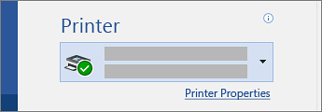

**Use shortcuts for Microsoft Outlook**

This table shows the most frequently used shortcuts in Outlook Windows.

| **Action** | **Shortcut Keys** |
| --- | --- |
| Close a window or a menu. | Esc |
| Go to the Home tab. | Alt+H |
| Create a new message. | Ctrl+Shift+M |
| Send a message. | Alt+S |
| Insert a file. | Alt+N, A, F |
| New task | Ctrl+Shift+K |
| Delete an item (when a message, task, or meeting is selected). | Delete |
| Search for an item. | Ctrl+E or F3 |
| Reply to a message. | Alt+H, R, P |
| Forward a message. | Alt+H, F, W |
| Select the Reply All option. | Alt+H, R, A |
| Copy an item. | Ctrl+C |
| Go to the Send/Receive tab. | Alt+J, S |
| Go to Calendar. | Ctrl+2 |
| Create an appointment. | Ctrl+Shift+A |
| Move an item to a folder. | Alt+H, M, V, and select a folder from the list |
| Open the Save As dialog on the Attachment tab. | Alt+J, A, A, V |
| Check for new messages. | Ctrl+M or F9 |