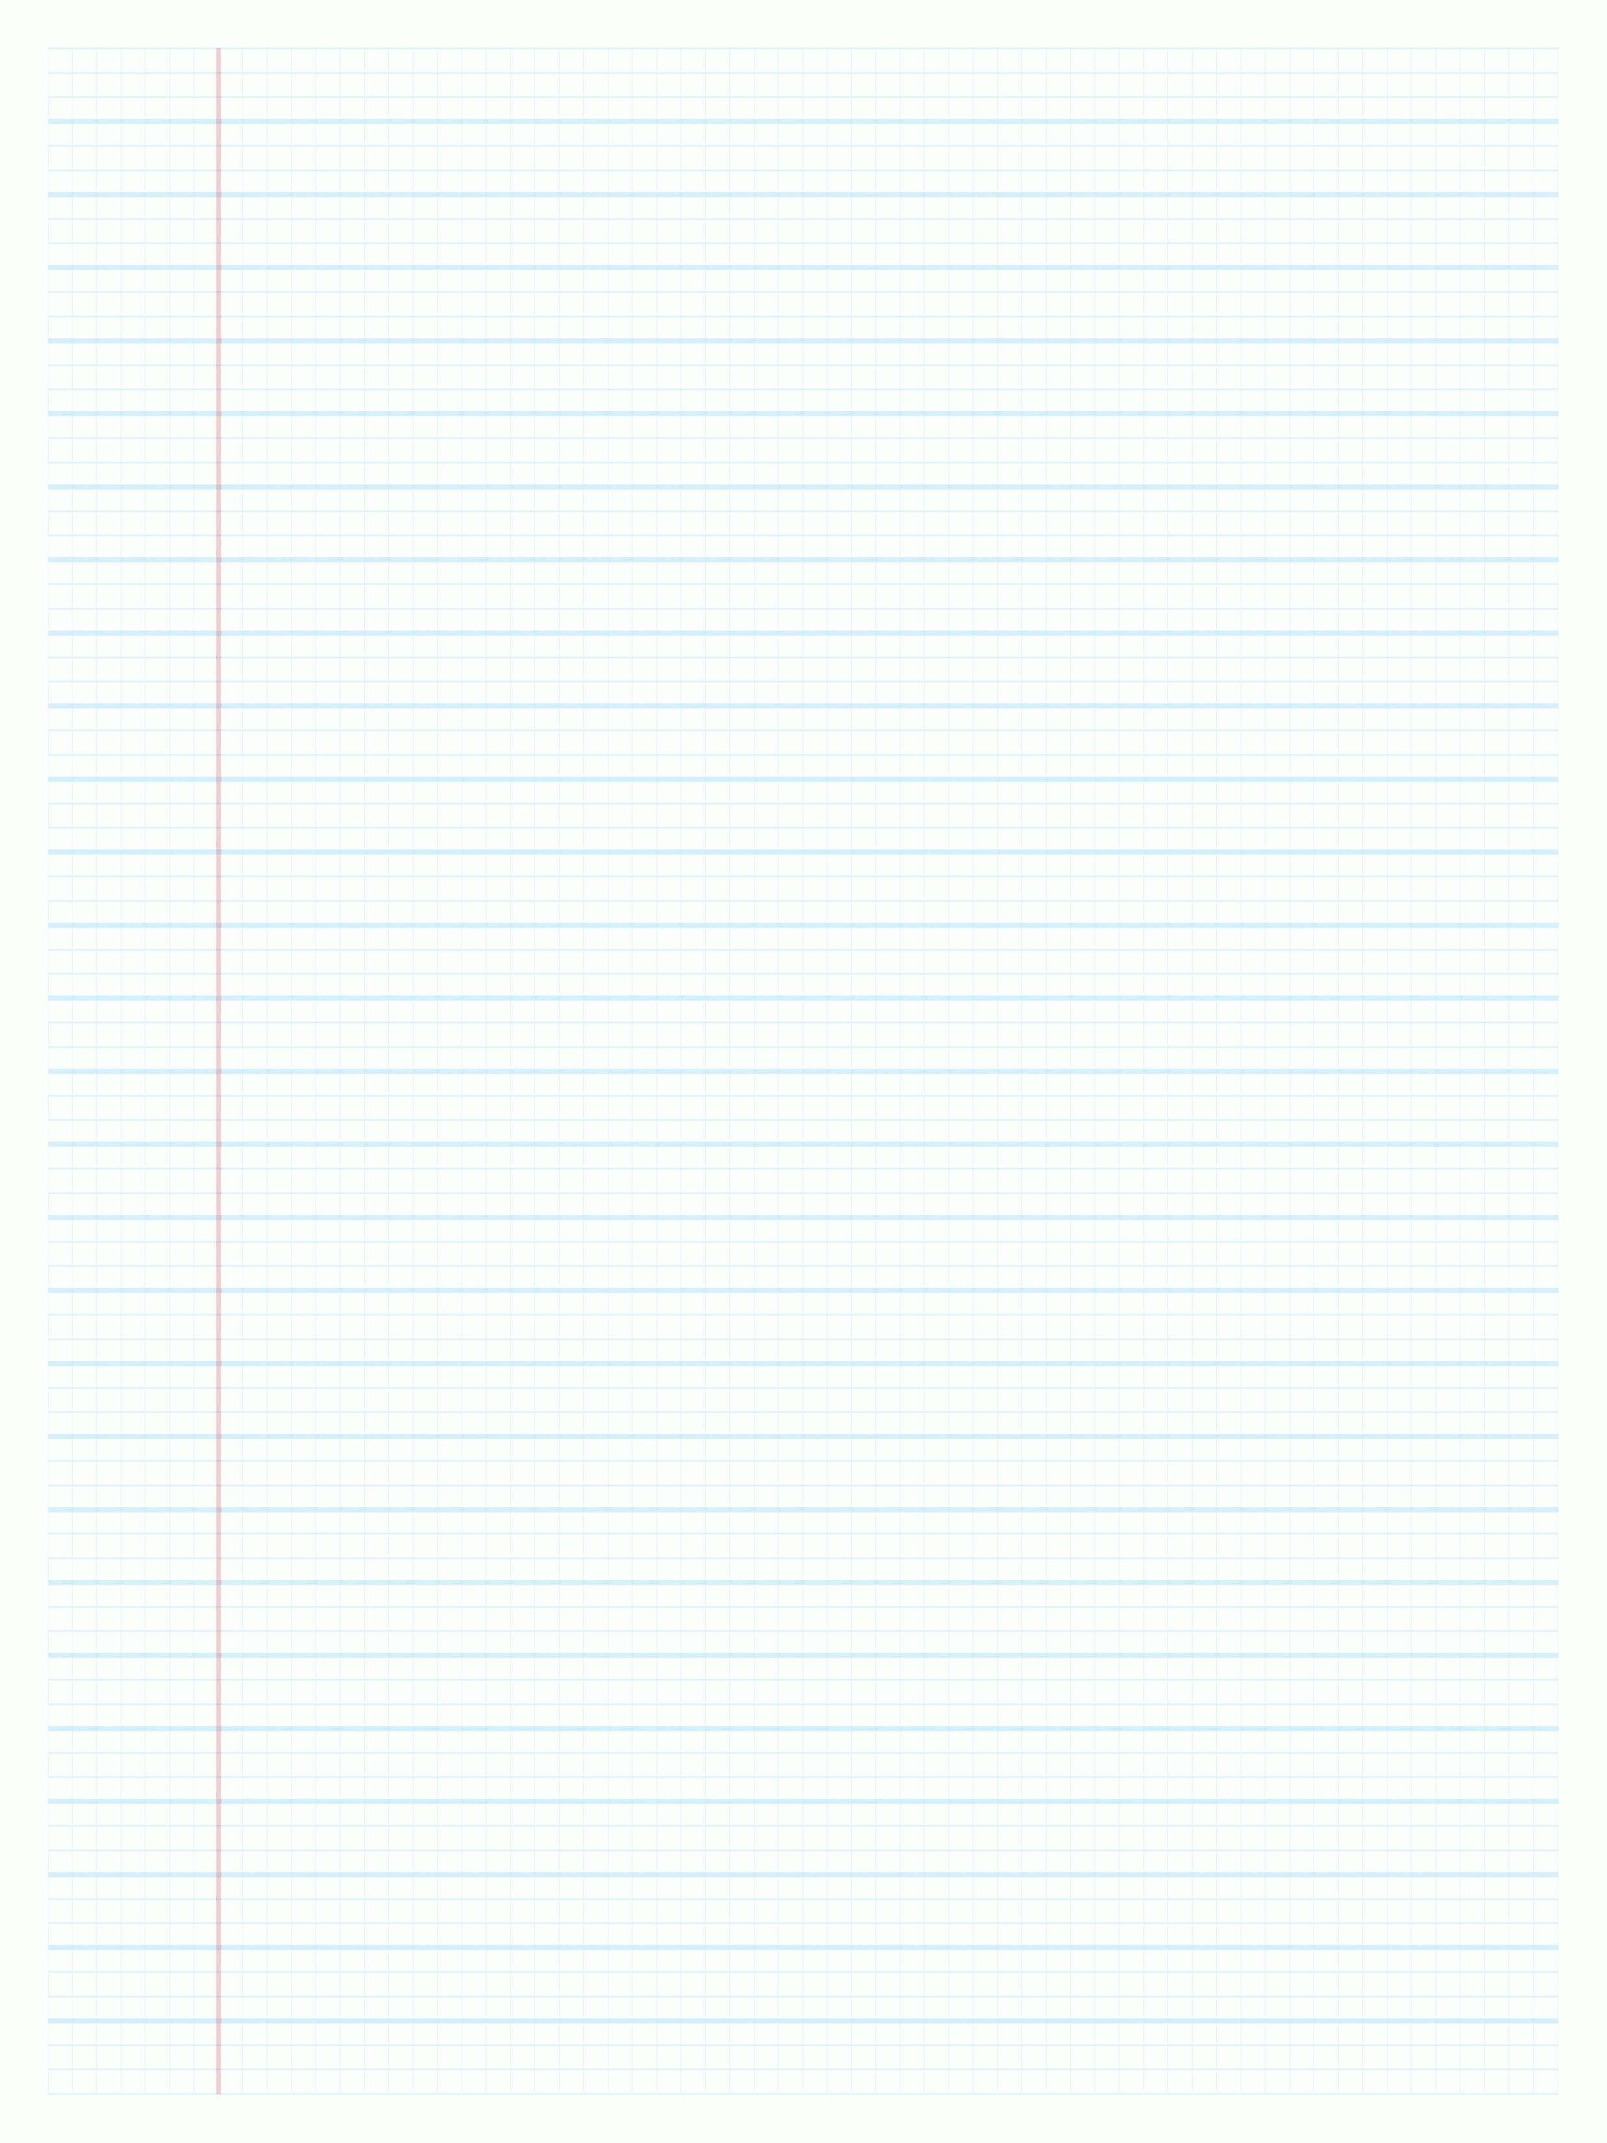

**You can use this notebook to keep a record of sources you have discovered and useful information you have found during the course of your research.**

**Remember to note down details of sources in order to help you find them again in the future and to enable you to write a good bibliography. Write down any quotes you wish to use in full with page references where appropriate.**

**The questions below will help you to decide which will be the best sources to use.**

**Questions to ask about the reliability of a source**

Look at the presentation of a website – does it look professional?

Check the spelling and grammar used on websites – can you spot any mistakes?

Check when a website was last updated. Does it have out-of-date information or broken links?

Is the author knowledgeable about the subject? Are they an established writer or expert?

Is the source biased – are the arguments logical and backed up with evidence?

Is a website trying to sell you something?

Who is the publisher – what organisation has produced a website (check homepages if you are using a Google search)?

Does a book look like it has been produced cheaply?

Has the website been translated from another language? Is it a good translation?

**Questions to ask about the relevance of sources**

Is the information too general or too complicated?

Is the information up-to-date? If you are looking for historical information – does it cover the right time period?

What country does the source come from? Is this important for the topic you are researching?

What readership is the source intended for – is it at a high enough level?

Read your essay question again – will the source help you to answer this?

Useful books

Useful online resources

Useful journal articles, reports, leaflets etc.