Intermediate guide on how to use Microsoft Teams



|  |  |
| --- | --- |
| **guide on How To:** | **Page Number** |
| Download/Open application | 2 |
| Start a new conversation... with class/person | 2 |
| Reply to a conversation | 3 |
| Make video and audio calls from a chat | 3 |
| Share a file | 4 |
| @mention someone | 4 |
| Search for messages, people, or files | 5 |
| View/Join meetings | 6 |
| Share your screen | 6 |
| Present in an online meeting, show your PowerPoint slides right from the Microsoft Teams meeting menu. | 6 |
| Use shortcuts for Microsoft Teams (General & Navigation) | 7 |
| Use shortcuts for Microsoft Teams (Messaging & Meeting/Calls) | 8 |

**Download Application**

You can download Microsoft 365 for free on your PC/Laptop, Tablet or Smartphone using your Microsoft 365 login:

* **Microsoft 365 username** [studentnumber@fecolleges.london](mailto:studentnumber@fecolleges.london) and password

(e.g. [S0123456@fecolleges.london](mailto:S0123456@fecolleges.london) / [AC102356@fecolleges.london](mailto:AC102356@fecolleges.london) / [20123456@fecolleges.london](mailto:20123456@fecolleges.london))

**PC/Laptop**

1. Open link using your web browser: <https://www.microsoft.com/en-gb/microsoft-365>
2. Sign in with your **Microsoft 365 username** and password.
3. Select **Install** located at the top right of the web page.

**Tablet/Smartphone**

1. Search **Teams** on Apple App Store/Google Play and **download**.
2. Open application and sign in with your **Microsoft 365 username** and password.

**Open Application**

1. Search your computer for Microsoft Teams and open.
   * In Windows, click **Start** Start button > **Microsoft Teams**.
   * On Mac, go to the **Applications** folder and click **Microsoft Teams**.
   * On Tablet/Smartphone, tap the **Teams** icon.
2. Sign in with your **Microsoft 365 username** and password

**Start a new conversation...**

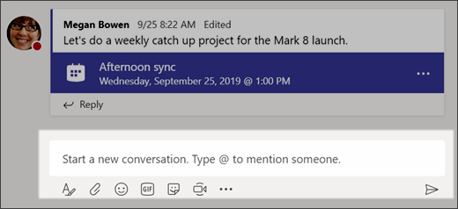**...with the whole team/class**

1. Click **Teams** Teams button , you should see the class you are enrolled. If you do not see a Team, then please contact Learner Services Department or your Tutor.
2. In the box where you type your message, say what's on your mind and click **Send** Send button .

**...with a person or group**

1. At the top of the app, click **New chat** New chat button .
2. In the **To** field, type the name of the person or people you want to chat with.
3. In the box where you type your message, say what's on your mind and click **Send** Send button .

**Reply to a conversation**

Channel conversations are organized by date and then threaded. The replies in threads are organized under the initial post so it's easier to follow multiple conversations.

1. Find the conversation thread you want to reply to.
2. Click **Reply**, add your message, and click **Send**Send button .

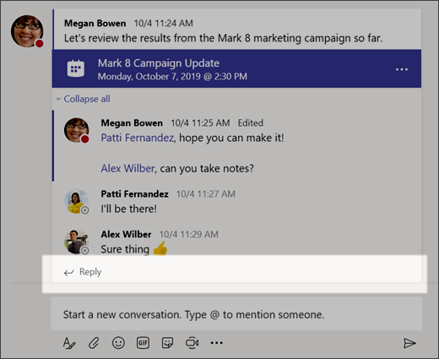

**Make video and audio calls from a chat**

* Select **Video call** Select to start a video call. or **Audio call** Select to start an audio call. to call someone directly from a chat.

**Share a file**

Sometimes words aren't enough, and you need to post a file to a channel conversation.

**Tip:** Teams works particularly well with Microsoft Office documents.

1. In your channel conversation, click **Attach** Choose file buttonunder the box where you type your message.

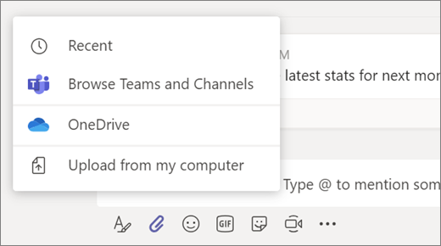

1. Select from these options:
   * **Recent**
   * **Browse Teams and Channels**
   * **OneDrive**
   * **Upload from my computer**
2. Select a file > **Share a link**.

If you're uploading a file from your computer, select a file, click **Open**, and then **Send** Send button .

You can always see all the files you post to a channel by going to the **Files** tab.

**@mention someone**

An @mention is like a tap on the shoulder — a way to get someone's attention in a channel conversation or a chat.

1. In the box where you type your message, type **@**, then type the first few letters of the person’s name. You can also @mention entire teams and channels.
2. Select the person. Repeat for as many people as you want to @mention.

Each person you @mention gets a notification in their **Activity** feed. Check for a red circle next to **Activity** Activity button right now to see if someone has @mentioned you!

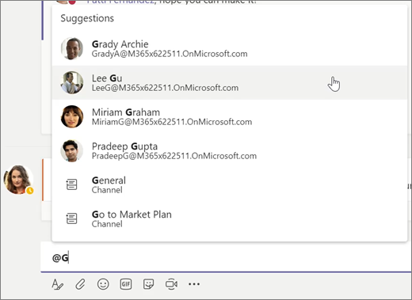

**Stay on top of things**

Notifications let you know when someone @mentions you, likes something you’ve posted, or replies to a thread you started. The Activity feed helps you stay on top of all your notifications.

1. Click **Activity** Activity button .
2. **Feed** shows you a summary of everything that's happened in the channels you follow.
   * Click **Filter** Filter button to show only certain types of notifications such as @mentions or reactions.
   * Select **Feed** > **My Activity** to see a list of everything you've been up to lately in Teams.

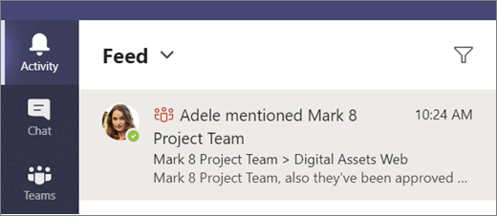

**Search for messages, people, or files**

Searches cover your entire organization — all the teams and channels that you are joined to.

1. Type a phrase in the command box at the top of the app and press Enter.
2. Select the **Messages**, **People**, or **Files** tab.
3. Select an item in the search results. Alternatively, you can select **More filters** to further refine your search results.

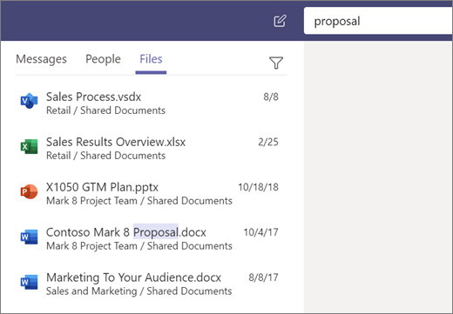

**View meetings**

1. Select **Calendar** to view your appointments and meetings for the day or work week.

These appointments are matched with your Outlook calendar.

1. Select a meeting invite to see what the meeting's about, who's attending, and to respond to the meeting.

**Join a Teams meeting from the app**

1. In a Teams meeting invite, select **Join**.
2. **Join Microsoft Teams Meeting**: Enter a meeting from your Teams meeting invite.
3. Choose the audio and video settings you want.
4. Select **Join now**.

**Join a Teams meeting on the web**

Don't have the Teams app? You can still join a Teams meeting.

1. In your email invite sent to your college email address, select **Join Microsoft Teams Meeting**.

**Share your screen**

In Microsoft Teams, you can show your desktop, a specific app, presentation, or any file while in a meeting.

* Select the share screen icon  Select to share your screen in a meeting. to show your screen to the other people in the meeting.
* Select more options icon  Select to see more options to record the meeting. You'll be emailed when the video is ready so you can view, edit, and share with others.

1. Select **Share** Share screen button .
2. Select what you want to share:
   * **Desktop** lets you show everything on your screen.
   * **Window** lets you show a specific app.
   * **PowerPoint** lets you show a presentation.
   * **Browse** lets you find the file you want to show.
3. After you select what you want to show, a red border surrounds what you're sharing.
4. Select **Stop sharing** to stop showing your screen.

**Present in an online meeting, show your PowerPoint slides right from the Microsoft Teams meeting menu.**

**If you're a presenter**

1. Select **Share**.
2. Choose a presentation under the **PowerPoint** category.

**If you're a meeting participant**

1. Select **Navigate forward** to move forward in a presentation without interrupting the presenter.

**Note:** The presenter must share the file from the PowerPoint category for participants to skip around during a presentation.

1. Select **To presenter** to sync your view back to the presenter's when you want.

**Use shortcuts for Microsoft Teams**

This table shows the most frequently used shortcuts in Teams Windows.

**General**

| Action | In the Desktop app, shortcut keys | In the Web app, shortcut keys |
| --- | --- | --- |
| Show keyboard shortcuts | Ctrl+Period (.) | Ctrl+Period (.) |
| Go to **Search** | Ctrl+E | Ctrl+E |
| Show commands | Ctrl+Slash (/) | Ctrl+Slash (/) |
| Goto | Ctrl+G | Ctrl+Shift+G |
| Start a new chat | Ctrl+N | Left Alt+N |
| Open **Settings** | Ctrl+Comma (,) | Ctrl+Comma (,) |
| Open **Help** | F1 | Ctrl+F1 |
| Close | Esc | Esc |
| Zoom in | Ctrl+Equals sign (=) | No shortcut |
| Zoom out | Ctrl+Minus sign (-) | No shortcut |

**Navigation**

| Action | In the Desktop app, shortcut keys | In the Web app, shortcut keys |
| --- | --- | --- |
| Open **Activity** | Ctrl+1 | Ctrl+Shift+1 |
| Open **Chat** | Ctrl+2 | Ctrl+Shift+2 |
| Open **Teams** | Ctrl+3 | Ctrl+Shift+3 |
| Open **Calendar** | Ctrl+4 | Ctrl+Shift+4 |
| Open **Calls** | Ctrl+5 | Ctrl+Shift+5 |
| Open **Files** | Ctrl+6 | Ctrl+Shift+6 |
| Go to previous list item | Left Alt+Up arrow key | Left Alt+Up arrow key |
| Go to next list item | Left Alt+Down arrow key | Left Alt+Down arrow key |
| Move selected team up | Ctrl+Shift+Up arrow key | No shortcut |
| Move selected team down | Ctrl+Shift+Down arrow key | No shortcut |
| Go to previous section | Ctrl+Shift+F6 | Ctrl+Shift+F6 |
| Go to next section | Ctrl+F6 | Ctrl+F6 |

**Messaging**

| Action | In the Desktop app, shortcut keys | In the Web app, shortcut keys |
| --- | --- | --- |
| Go to compose box | C | C |
| Expand compose box | Ctrl+Shift+X | Ctrl+Shift+X |
| Send (expanded compose box) | Ctrl+Enter | Ctrl+Enter |
| Attach file | Ctrl+O | Ctrl+Shift+O |
| Start new line | Shift+Enter | Shift+Enter |
| Reply to thread | R | R |
| Mark as important | Ctrl+Shift+I | Ctrl+Shift+I |

**Meetings and Calls**

| Action | In the Desktop app, shortcut keys | In the Web app, shortcut keys |
| --- | --- | --- |
| Accept video call | Ctrl+Shift+A | Ctrl+Shift+A |
| Accept audio call | Ctrl+Shift+S | Ctrl+Shift+S |
| Decline call | Ctrl+Shift+D | Ctrl+Shift+D |
| Start audio call | Ctrl+Shift+C | Ctrl+Shift+C |
| Start video call | Ctrl+Shift+U | Ctrl+Shift+U |
| Toggle mute | Ctrl+Shift+M | Ctrl+Shift+M |
| Toggle video | Ctrl+Shift+O | No shortcut |
| Filter current list | Ctrl+Shift+F | Ctrl+Shift+F |
| Go to sharing toolbar | Ctrl+Shift+Space | Ctrl+Shift+Space |